FOR IMMEDIATE RELEASE
NEWS RELEASE
Media Contact: Tricia Pancio
503.241.9807, ext. 102, trisha@artistsrep.org

Artists Repertory Theatre Premieres The Ghosts of Celilo

Ground-breaking musical weaves a bittersweet love story within a mystery
in this cross-cultural collaborative production by Quarterflash founder Marv Ross.

Artists Repertory Theatre and Youth Resources, Inc. co-present The Ghosts of Celilo (suh-LIE-low), a powerful musical based on true stories from the Columbia River, The Ghosts of Celilo tells of three children’s quest to escape a boarding school and catch their ceremonial first salmon before their home is destroyed by the rising waters behind a dam. The play is presented as part of the 50-year observance of the inundation of Celilo Falls by The Dalles Dam in 1957. The production will have its world premiere in the Newmark Theater in the Portland Center for the Performing Arts from September 28th through October 14th 2007. Performance times are Thursday through Saturday at 7:30 PM, and Sunday at 2:00 PM. Ticket prices are $21.50 to $50.00, and are available through both Ticketmaster and the PCPA Box Office at 1111 SW Broadway in downtown Portland.

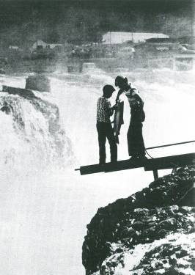
The Ghosts of Celilo was created by Ross, Thomas Morning Owl, and Tom Hampson based on interviews conducted with people on the river, most notably, the late Warm Springs elder, Nathan Jim Sr., who was kidnapped from Celilo Village in 1949. The score was composed collaboratively by Ross, Mel Kubik, and Native musicians Chenoa Egawa, Arlie Neskahi, and Fred Hill. The orchestra for the shows features members of The Trail Band and Quarterflash as well as Ross’s wife, singer/saxophonist, Rindy Ross. The 22-member cast of Native and non-Native actors will be directed by Drammy Award winner, Greg Tamblyn.

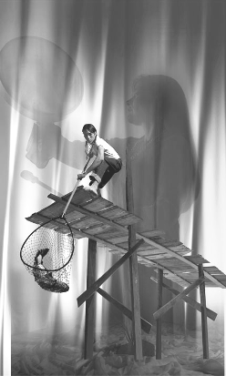
As the musical opens, four restless ghosts stuck below the drowned Falls are awakened by a toy whistle thrown into the current. The whistle passes from the hands of one ghost to the next, unraveling a mystery as to the identity of two boys, kidnapped from Celilo and sent to missionary school, where they befriend the daughter of a white administrator. The three attempt a dramatic escape, racing back to Celilo Falls in hopes of catching their ceremonial first salmon only to find their homelands flooded by the creation of the new dam. It’s an adventure that will change the boys’ life forever… and offer redemption for the four souls stuck at the bottom of the river.

“When Marv first brought me a draft of this play, I was deeply intrigued by the possibilities of a Native Oregon musical,”
explains Artists Repertory Theatre Artistic Director Allen Nause.
“Now I feel even more privileged to participate in its launch
to the regional and national stage.”

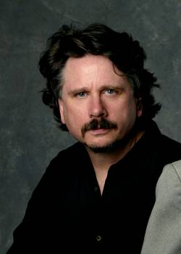
Playwright/Composer Marv Ross is a musician, producer, songwriter, and playwright. He and his wife, Rindy, are best known for their songs they recorded as Quarterflash (Harden My Heart) and with The Trail Band - a group he assembled for his first musical, Voices From The Oregon Trail. Marv received an American Society of Composers and Authors (ASCAP) Special Award for that work and was invited to participate in the Kennedy Center's "New Voices" workshop where he and Native American singer, Chenoa Egawa created the score for Oregon Children's Theatre's Sacagawea. In 2005, he and Egawa were awarded a National Alliance of Musical Theatres grant to create a score for Marv's new play, The Ghosts of Celilo. Marv has written songs with Burt Bacharach, Diane Warren, and Carol Bayer Sager and he was awarded Western Oregon University's Alumni Award of Excellence for his contributions to Northwest history and music. He and Rindy were will be inducted into the Oregon Music Hall of Fame this fall.

The cast is Noah Hunt – Lumbee Nation (Chokey Jim), Chenoa Egawa – Lummi/ S’Klallam Nations (Mary), Corey Brunish (Colonel Biggs), Kevin Michael Moore (Inky), Thomas Morning Owl - Umatilla/Blood Nations (Big Eddie), Marissa Ryder (Irene), Colton Lasater (Train), Amy Jo Arrington (Mrs. Lyle), Tila Salas – Yurok Nation (Janie), and Albert Worthington – Klamath/Azteca Nations (Andy). The play is directed by Greg Tamblyn.

This production is generously supported by Spirit Mountain Community Fund, Bonneville Power Administration, The Kinsman Foundation, The Marie Lamfrom Charitable Foundation, The James F. and Marion L. Miller Fund II of The Oregon Community Foundation, The Regional Arts and Culture Council, Oregon Cultural Trust, The National Endowment for the Arts, The Irwin Foundation, The Collins Foundation, PGE Foundation, The Roundhouse Foundation, The Dorothea M. Lensch Fund of Oregon Community Foundation, The King-Guffey Foundation, Tamastslikt Cultural Institute, Wildhorse Resort and Casino, The Campbell Group, Hollywood Lighting, Shiels Obletz Johnson, The Portland Center for the Performing Arts, George Morlan Plumbing, Williams & Dame Development, and many individuals.
Founded in 1982, Artists Repertory Theatre celebrates its 25th season as Portland, Oregon’s oldest professional theater company. Artists Rep is dedicated to challenging artists and audiences with plays of depth and vibrancy in an intimate environment. Under the artistic leadership of Allen Nause, Artists Rep explores the strengths, frailties, and diversity of the human condition primarily through regional premieres, commissioned works, and selected classics appropriate to contemporary issues. The company is committed to enhancing the artistic culture of Portland and the region by establishing and maintaining education and outreach programs consistent with the artistic mission of the company. For more information contact Trisha Pancio at 503.241.9807 ext 102.
###

